[SQL SERVER TUTORIAL](https://www.sqlservertutorial.net/)

* [HOME](https://www.sqlservertutorial.net/)
* [START HERE](https://www.sqlservertutorial.net/getting-started/)
* [BASIC](https://www.sqlservertutorial.net/sql-server-basics/)
* [ADVANCED](https://www.sqlservertutorial.net/sql-server-triggers/sql-server-instead-of-trigger/)
  + [Views](https://www.sqlservertutorial.net/sql-server-views/)
  + [Indexes](https://www.sqlservertutorial.net/sql-server-indexes/)
  + [Stored Procedures](https://www.sqlservertutorial.net/sql-server-stored-procedures/)
  + [User-defined Functions](https://www.sqlservertutorial.net/sql-server-user-defined-functions/)
  + [Triggers](https://www.sqlservertutorial.net/sql-server-triggers/)
* [FUNCTIONS](https://www.sqlservertutorial.net/sql-server-triggers/sql-server-instead-of-trigger/)
  + [Aggregate Functions](https://www.sqlservertutorial.net/sql-server-aggregate-functions/)
  + [Date Functions](https://www.sqlservertutorial.net/sql-server-date-functions/)
  + [String Functions](https://www.sqlservertutorial.net/sql-server-string-functions/)
  + [System Functions](https://www.sqlservertutorial.net/sql-server-system-functions/)
  + [Window Functions](https://www.sqlservertutorial.net/sql-server-window-functions/)

[Home](https://www.sqlservertutorial.net/) / [SQL Server Triggers](https://www.sqlservertutorial.net/sql-server-triggers/) / SQL Server INSTEAD OF Trigger

SQL Server INSTEAD OF Trigger

**Summary**: in this tutorial, you will learn how to use SQL Server INSTEAD OF trigger to insert data into an underlying table via a view.

What is an INSTEAD OF trigger

An INSTEAD OF trigger is a trigger that allows you to skip an [INSERT](https://www.sqlservertutorial.net/sql-server-basics/sql-server-insert/), [DELETE](https://www.sqlservertutorial.net/sql-server-basics/sql-server-delete/), or [UPDATE](https://www.sqlservertutorial.net/sql-server-basics/sql-server-update/) statement to a table or a view and execute other statements defined in the trigger instead. The actual insert, delete, or update operation does not occur at all.

In other words, an INSTEAD OF trigger skips a DML statement and execute other statements.

SQL Server INSTEAD OF trigger syntax

The following illustrates the syntax of how to create an INSTEAD OF trigger:

|  |  |
| --- | --- |
| 1  2  3  4  5 | CREATE TRIGGER [schema_name.] trigger_name  ON {table_name | view_name }  INSTEAD OF {[INSERT] [,] [UPDATE] [,] [DELETE] }  AS  {sql_statements} |

In this syntax:

* First, specify the name of the trigger and optionally the name of the schema to which the trigger belongs in the CREATE TRIGGER clause.
* Second, specify the name of the table or view which the trigger associated with.
* Third, specify an event such as INSERT, DELETE, or UPDATE which the trigger will fire in the INSTEAD OF clause. The trigger may be called to respond to one or multiple events.
* Fourth, place the trigger body after the AS keyword. A trigger’s body may consist of one or more Transact-SQL statements.

SQL Server INSTEAD OF trigger example

A typical example of using an INSTEAD OF trigger is to override an insert, update, or delete operation on a [view](https://www.sqlservertutorial.net/sql-server-views/).

Suppose, an application needs to insert new brands into the production.brands table. However, the new brands should be stored in another table called production.brand_approvals for approval before inserting into the production.brands table.

To accomplish this, you [create a view](https://www.sqlservertutorial.net/sql-server-views/sql-server-create-view/) called production.vw_brands for the application to insert new brands. If brands are inserted into the view, an INSTEAD OF trigger will be fired to insert brands into the production.brand_approvals table.

The following picture illustrates the process:

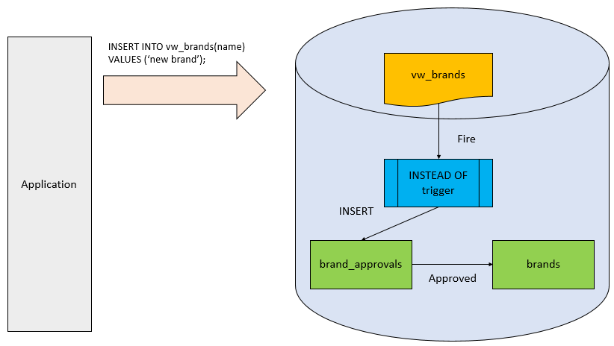

This diagram does not show the schema name of all the database objects for the sake of simplicity.

The following statement [creates a new table](https://www.sqlservertutorial.net/sql-server-basics/sql-server-create-table/) named production.brand_approvals for storing pending approval brands:

|  |  |
| --- | --- |
| 1  2  3  4 | CREATE TABLE production.brand_approvals(      brand_id INT IDENTITY PRIMARY KEY,      brand_name VARCHAR(255) NOT NULL  ); |

The following statement [creates a new view](https://www.sqlservertutorial.net/sql-server-views/sql-server-create-view/) named production.vw_brands against the production.brands and production.brand_approvals tables:

|  |  |
| --- | --- |
| 1  2  3  4  5  6  7  8  9  10  11  12  13 | CREATE VIEW production.vw_brands  AS  SELECT      brand_name,      'Approved' approval_status  FROM      production.brands  UNION  SELECT      brand_name,      'Pending Approval' approval_status  FROM      production.brand_approvals; |

Once a row is inserted into the production.vw_brands view, we need to route it to the production.brand_approvals table via the following INSTEAD OF trigger:

|  |  |
| --- | --- |
| 1  2  3  4  5  6  7  8  9  10  11  12  13  14  15  16  17  18  19  20  21 | CREATE TRIGGER production.trg_vw_brands  ON production.vw_brands  INSTEAD OF INSERT  AS  BEGIN      SET NOCOUNT ON;      INSERT INTO production.brand_approvals (          brand_name      )      SELECT          i.brand_name      FROM          inserted i      WHERE          i.brand_name NOT IN (              SELECT                  brand_name              FROM                  production.brands          );  END |

The trigger inserts the new brand name into the production.brand_approvals if the brand name does not exist in the production.brands.

Let’s insert a new brand into the production.vw_brands view:

|  |  |
| --- | --- |
| 1  2 | INSERT INTO production.vw_brands(brand_name)  VALUES('Eddy Merckx'); |

This INSERT statement fired the INSTEAD OF trigger to insert a new row into the production.brand_approvals table.

If you query data from the production.vw_brands table, you will see a new row appear:

|  |  |
| --- | --- |
| 1  2  3  4  5 | SELECT  brand_name,  approval_status  FROM  production.vw_brands; |

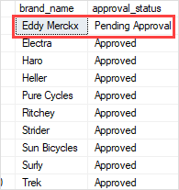

The following statement shows the contents of the production.brand_approvals table:

|  |  |
| --- | --- |
| 1  2  3  4 | SELECT  *  FROM  production.brand_approvals; |

SQL Server INSTEAD OF trigger - pending table

In this tutorial, you have learned about SQL Server INSTEAD OF trigger and how to create an INSTEAD OF trigger for inserting data into an underlying table via a view.

* Was this tutorial helpful ?
* [YesNo](https://www.sqlservertutorial.net/sql-server-triggers/sql-server-instead-of-trigger/)



[Previous Tutorial:SQL Server CREATE TRIGGER](https://www.sqlservertutorial.net/sql-server-triggers/sql-server-create-trigger/)

[Next Tutorial:SQL Server DDL Trigger](https://www.sqlservertutorial.net/sql-server-triggers/sql-server-ddl-trigger/)

Top of Form



Bottom of Form

GETTING STARTED

* [What is SQL Server](https://www.sqlservertutorial.net/getting-started/what-is-sql-server/)
* [Install the SQL Server](https://www.sqlservertutorial.net/install-sql-server/)
* [Connect to the SQL Server](https://www.sqlservertutorial.net/connect-to-the-sql-server/)
* [SQL Server Sample Database](https://www.sqlservertutorial.net/sql-server-sample-database/)
* [Load Sample Database](https://www.sqlservertutorial.net/load-sample-database/)

TRIGGERS

* [Creating After DML Triggers](https://www.sqlservertutorial.net/sql-server-triggers/sql-server-create-trigger/)
* [Creating INSTEAD OF Triggers](https://www.sqlservertutorial.net/sql-server-triggers/sql-server-instead-of-trigger/)
* [Creating DDL Triggers](https://www.sqlservertutorial.net/sql-server-triggers/sql-server-ddl-trigger/)
* [Disabling Triggers](https://www.sqlservertutorial.net/sql-server-triggers/sql-server-disable-trigger/)
* [Enabling Triggers](https://www.sqlservertutorial.net/sql-server-triggers/sql-server-enable-trigger/)
* [Viewing Definition of Triggers](https://www.sqlservertutorial.net/sql-server-triggers/sql-server-view-trigger-definition/)
* [Listing All Triggers](https://www.sqlservertutorial.net/sql-server-triggers/sql-server-list-all-triggers/)
* [Removing Triggers](https://www.sqlservertutorial.net/sql-server-triggers/sql-server-drop-trigger/)

ABOUT SQLSERVERTUTORIAL.NET

SQLServerTutorial.net website designed for Developers, Database Administrators, and Solution Architects who want to get started SQL Server quickly.

Top of Form



Bottom of Form

RECENT TUTORIALS

* [SQL Server Synonym](https://www.sqlservertutorial.net/sql-server-basics/sql-server-synonym/)
* [SQL Server DROP SCHEMA](https://www.sqlservertutorial.net/sql-server-basics/sql-server-drop-schema/)
* [SQL Server ALTER SCHEMA](https://www.sqlservertutorial.net/sql-server-basics/sql-server-alter-schema/)
* [SQL Server CREATE SCHEMA](https://www.sqlservertutorial.net/sql-server-basics/sql-server-create-schema/)
* [SQL Server SYSDATETIMEOFFSET Function](https://www.sqlservertutorial.net/sql-server-date-functions/sql-server-sysdatetimeoffset-function/)

SITE LINKS

* [About](https://www.sqlservertutorial.net/about/)
* [Contact](https://www.sqlservertutorial.net/contact/)
* [Privacy Policy](https://www.sqlservertutorial.net/privacy/)
* [Terms of Use](https://www.sqlservertutorial.net/terms-of-use/)

Copyright © 2020 by www.sqlservertutorial.net. All Rights Reserved.

⤒